Media Library

Access Media Library at https://medialibrary.gs1nz.org
How to Download an Image
- Search
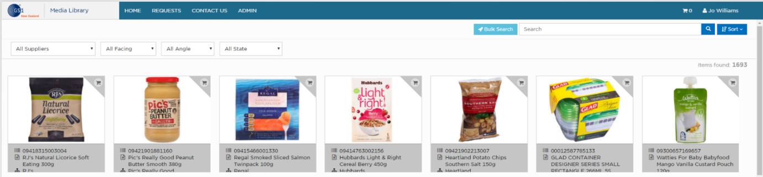
Select Supplier, Facing, Orientation and/or State. (For Planogram, select Front Facing and Orientation: no plunge)

Enter search criteria:
- Enter GTIN/barcode to find all assets for an item
- When searching for multiple requirements, put spaces between words not commas
- Put an * (asterisk) at the beginning of your search to return assets that contain those letters i.e. *peach
- Put “quotes” around your words to return an exact match
- Add brackets for combination search and separate terms by OR & AND i.e. (peach OR apple)

Or Click on one of the attributes displayed below an asset (highlighted in dark grey)
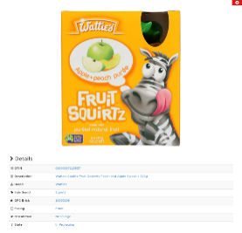

- View Asset

Click directly on an asset to display details

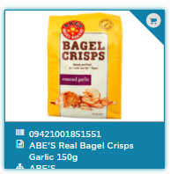
- Add Assets to Cart
To add an asset to cart for download, click in the top right corner.
The asset will be highlighted in blue.
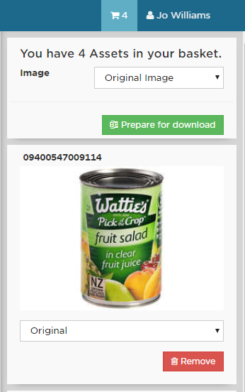
- Download Assets
b)
a)
c)
- Click on the cart at top right of screen to display all selected assets

- Select Type of asset - either all assets at top of screen or individually by asset.

- Click on “Prepare for Download” then “Download Now”
b)

- Select “Images Only” or “Image with Dimensions”

- Click on “Continue”

- Select either “Download Now” which will download the image on your local computer or copy the “One time link” which you can send to the intended recipient. 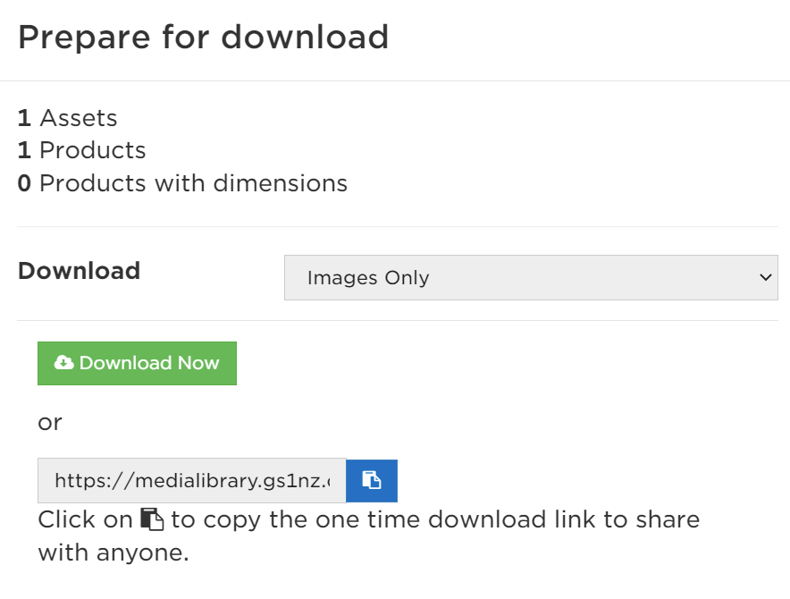

Assets are now ready for use.
Other Useful Tips

Orientation – “Plunge” refers to the angle of the photograph
Requests menu option. There may be assets that require authorisation for release to download. These assets will be highlighted in yellow when selected and will appear under this menu option if they have been included in a download.
Bulk Search – this can be used to quickly search for multiple assets. Upload a .txt or .csv file containing a single column of either:
Global Trade Item Numbers (barcodes)
Description
Brand
Sub-brand
GPC Brick
These assets can then all be added to the basket for download

