|  |
| --- |
| **NOTE! First time user?**  **Call the SUPPORT TEAM**  **on 0800 10 23 56**  **We'll make sure you are on the right track before you start!** |

**Introduction**

**ProductVault** is a central area in your MyGS1 account for storing details of your products.

If your company is a **new member of GS1** you can enter details of each product and the system will automatically allocate a barcode number from your range.

ProductVault is just for use within your company, so you and your colleagues can see which barcode number has been allocated to which product. And if you request a Verification Report, you will only need to enter the barcode number and the form will be populated from the details you have stored in ProductVault.

A **range** of barcode numbers has been allocated to your company. When you log into your MyGS1 account you can see the numbers by going to the menu on the left and clicking on Barcodes then clicking on ProductVault. The RANGE shows two 13-digit numbers, 'from' and 'to'. Under PRODUCTS it will show the number of products that have details already entered into ProductVault. Click on the number of products (eg '10 products') to see the details.  
  
If it shows '0 products' then no details have been entered. Is this because you are a **new company** and haven't put barcodes on your products yet? In this case you can go ahead and start using ProductVault.  
  
Or maybe you are an **existing company** and have been using your own system to put barcodes on items? In this situation you need to ensure that when you start using ProductVault the system allocates numbers which have not been used before. Call us and we can discuss with you on the best way to handle that.

Ready to go to the next step?

This document describes how to get a GTIN (barcode number) from your range for your new product by entering the details into your ProductVault.  
  
**FAQ’s**

1. ***I am new to barcoding***We run a free ‘Barcoding Quick Start Webinar’ every week. Register through our website www.[gs1nz.org](http://www.gs1nz.org/) (Services, Events and Training, Webinars) to get you on the right path.
2. ***I need to put a barcode on my new product*****\*STOP\*** do you already have products with barcodes on them? Call us, and we'll help you make sure that numbers haven't already been used on another product.All your products are already listed in ProductVault? The attached guide shows you how to use ProductVault to allocate the next available number in your range to the product. You will enter brief details of the product into the system.
3. **My products already have barcode numbers on them but the details are not stored in ProductVault.**  
   Call the Support Team and we can discuss the options with you. We can show you how to enter the details, or, if you have them in a spreadsheet we can load them for you.
4. ***I want to use my own system to allocate the next barcode***Call the Support Team to discuss using your own system.
5. **Terminology**  
   GTIN - Global Trade Item Number, also known as a bar code number  
   Bar code - strictly speaking the bar code is the graphic or image you see on products - the small lines - that are scanned by the reader.
6. **How do I view my items in ProductVault?**  
   In the menu on the left click on Barcodes then click on Barcodes then click on ProductVault, or scroll down to 'Bar Codes Allocated' on your Dashboard. Click on the words 'View Products'.  
     
   A line shows you the number of items in the block, Date Allocated, Range and Products. Click on the number of products (eg the words '22 products') to see what they are.   
   If it shows '0 products' then no details have been entered into ProductVault for that number range.
7. **Can I get a list of my items in ProductVault?**  
   Yes – you can download a list of all your products in Product Vault through a spreadsheet. Please see the “**Your data in a Spreadsheet”** section.

**Guide to Using ProductVault**

Log into your MyGS1 Account

From the menu on the left. select Barcodes then select ProductVault

Select the block of numbers you wish to use.

# Option 1: To use ProductVault to choose an available number for a new product

There are 4 levels of packaging. The Base Unit is the lowest level with a bar code on it. For Food & Grocery, this is the item that goes through point-of-sale. Base Units may go into an Inner Pack, or a Case, which may in turn go on to a Pallet. Barcodes are most commonly required on Base Units and Cases.   
The **Base Unit** has to be created first before you create the Case. When you create the **Case** the system will ask you to select the GTIN of the Base Unit/s in the Case, and the quantity (eg 20 items).  
Note that Inner Packs can only contain one type of Base Unit.  
  
**ACTION:**

1. Create the base unit: Choose your number range as shown below, select the option ‘Enter product information for a single new GTIN..’ . [Continue]  
     
   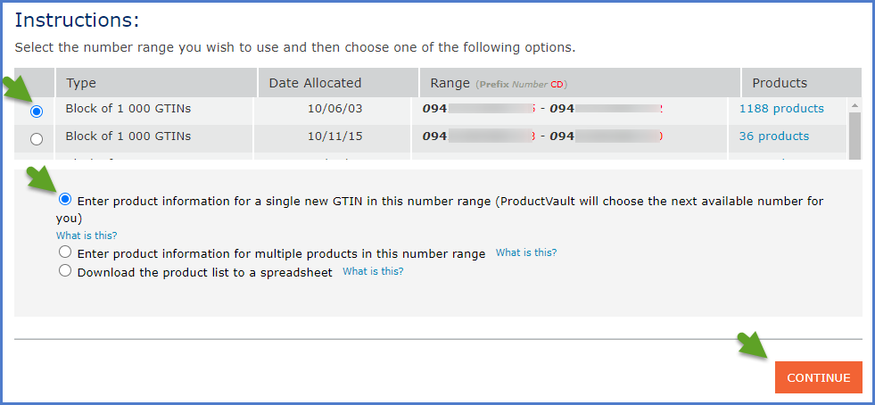
2. Note the **BASE** Unit must be entered first, before the Case. Select ‘Base’. [Next]  
   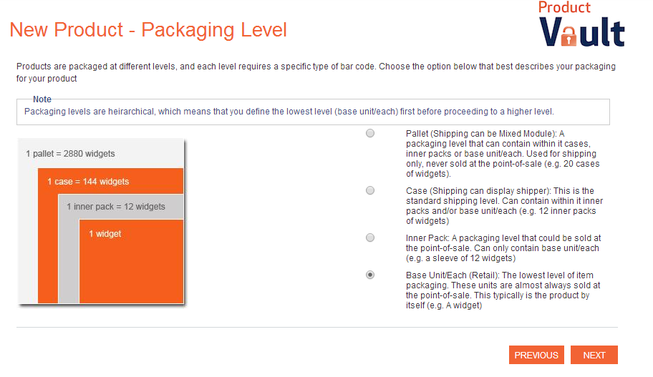
3. Choose an appropriate packaging type and click [NEXT].   
   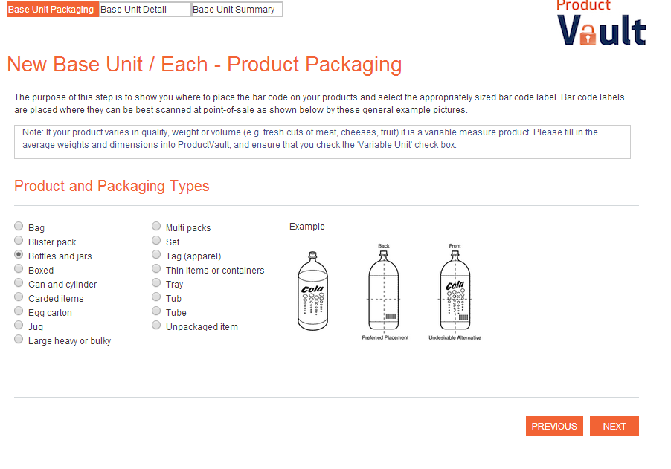
4. Fill in every field that has a red asterisk (mandatory fields). All other fields are optional. Click on ‘What is this?’ for more information about each field.  
   See below for an example, then click the orange [FINISH] button at the bottom of the page  
   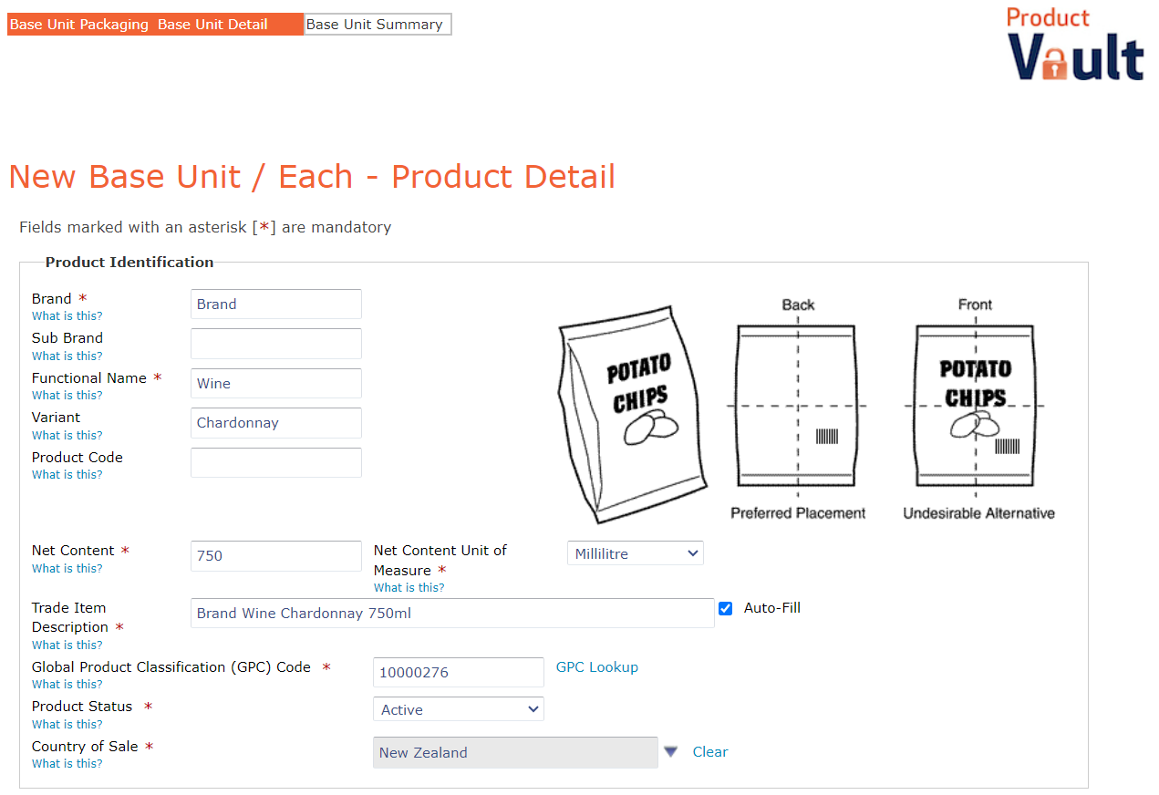
5. A GTIN (barcode number) has now been allocated.   
   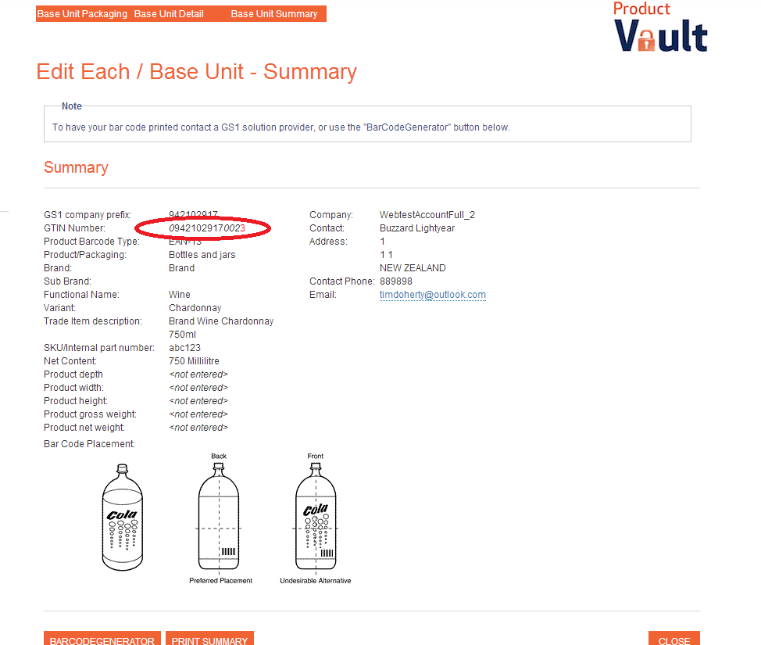
6. You have the option now to select the [Barcode Generator] button to take this GTIN and get a graphic (or you can get a graphic later), or [Print Summary]. Select [CLOSE] to finish.
7. Now you can follow the process again to enter details of the CASE. On the first screen ‘New Product – Packaging Level’ select CASE.  
   The system will then ask you which BASE UNIT will be in the Case. Select the Base Unit/s from the list under ‘Search Results’. [NEXT].
8. Enter details of the Case. Leave the Net Content fields blank. Enter the quantity of base units contained in the case in the field ‘How many of products listed are packed in the case?’.

# Option 2: To enter details for a product that already has a number on it *OR* create a Case GTIN with a number in the first position *OR* enter details for multiple items Select the number range you wish to use. Select the second option ’Enter product information for multiple products…’.

# Enter the product details in the next screen: If you want your CASE to start with a number other than 0 you can enter it here. You will need to know the barcode number. The system will calculate the check digit for you when you tab to the next field. For multiple products with the same or similar details, click the ‘lock’ symbol to keep the field value.

# 

# Once you have finished filling out the relevant details, click the ‘Add’ button to ready a the GTIN to be assigned. Repeat this process until you have readied all the GTINs you would like to assign and then select ‘Save Products’.

**Your data in a Spreadsheet**

If you would like the data in your ProductVault downloaded to a spreadsheet, you can select “Download the product list to a spreadsheet”.

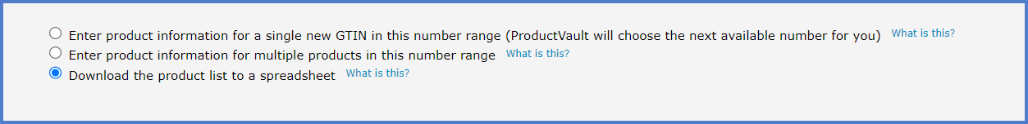

**Bulk uploading your product data by Spreadsheet**

If you would like to upload your data you can find how to do this here: <https://support.gs1nz.org/hc/en-us/articles/115002960652-Entering-data-in-your-ProductVault-Bulk-Upload>

++++++++++++++++++++++++++++++++++++++++++++++++++++++++++++++++++++++++++++++++++

*Any questions – call 0800 10 23 56 or email support@gs1nz.org*